Copyright for test papers and marking guides remains with West Australian Test Papers.
Test papers may only be reproduced within the purchasing school according to the advertised Conditions of Sale.
Test papers should be withdrawn after use and stored securely in the school until Friday 15th June 2018.

MATHEMATICS
METHODS
UNIT 3

Semester One

2018

SOLUTIONS

Calculator−free Solutions

1.. 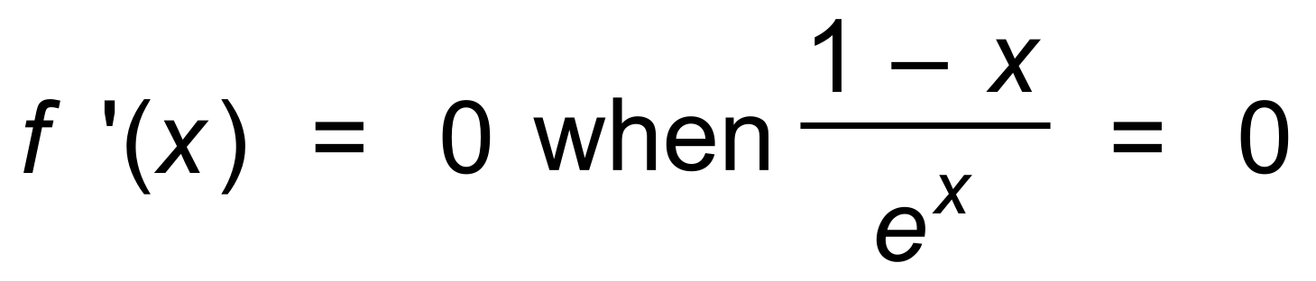
∴ x = 1
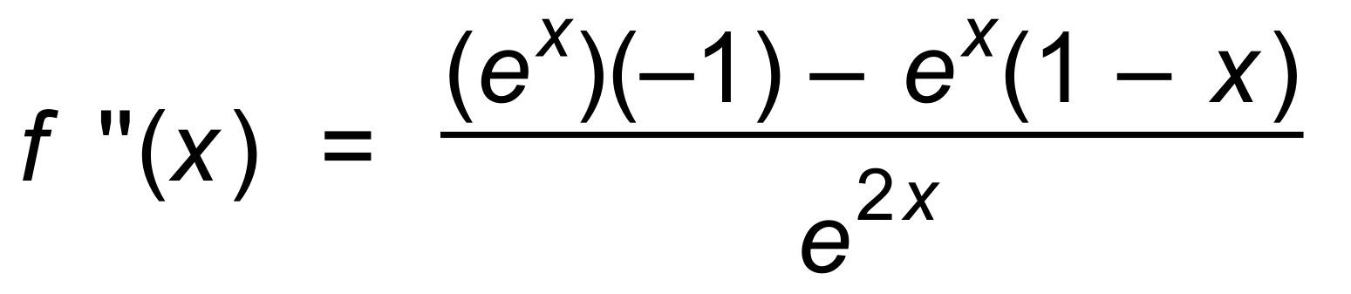
Since f ′′(1) < 0, then maximum
[4]

2. 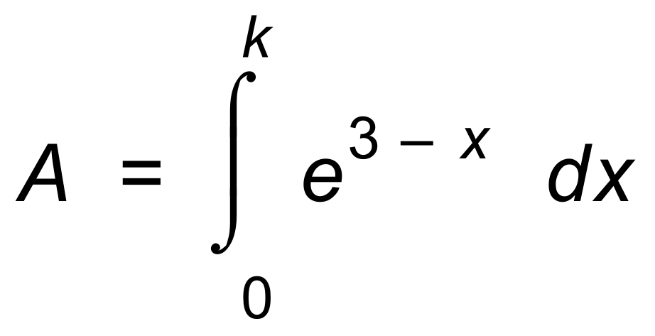
∴ 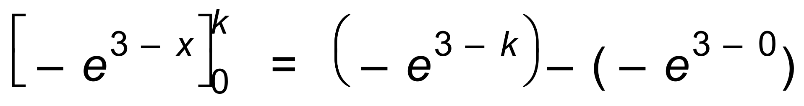
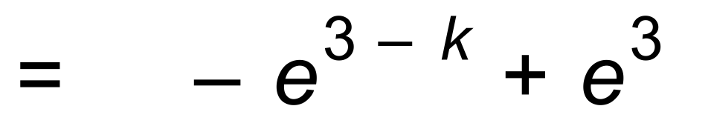
If 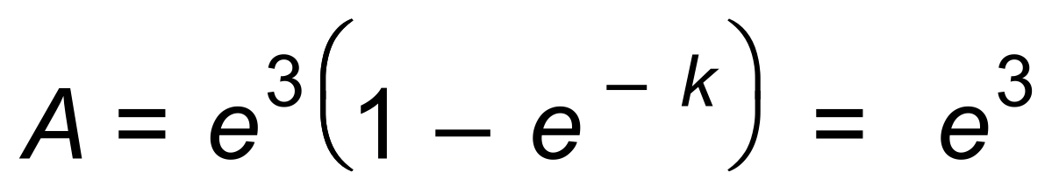 then 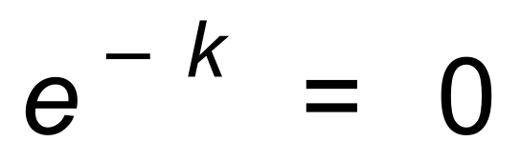, which is impossible.
If 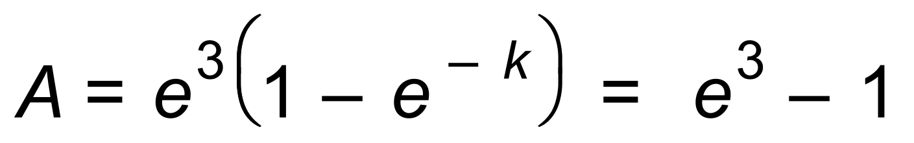
∴ k = 3 [6]

3. (a) Stationary point occurs when 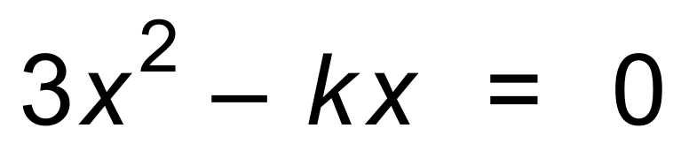
∴ 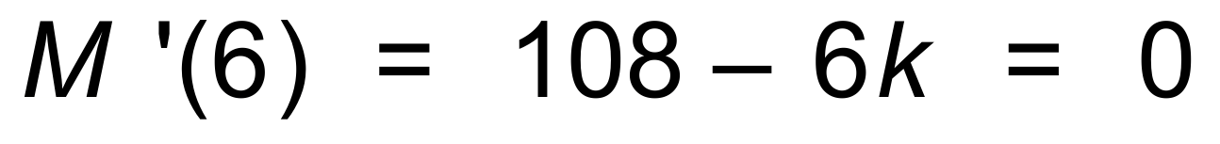
∴ k = 18
(b) 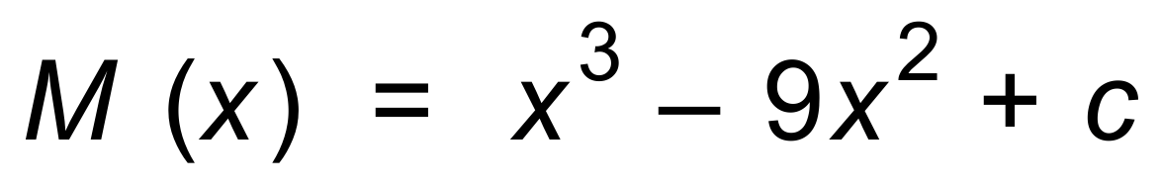
Since
∴ 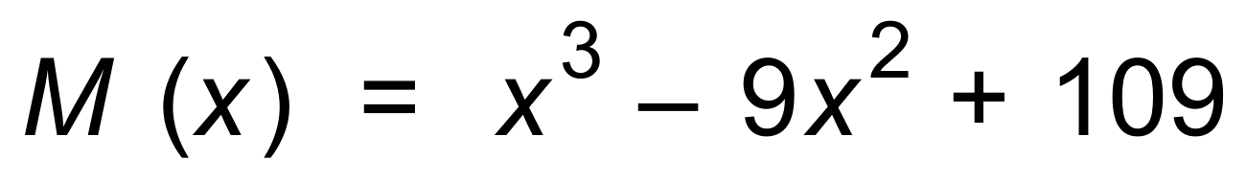
∴ Vertical intercept = 109 [6]

4. (a) 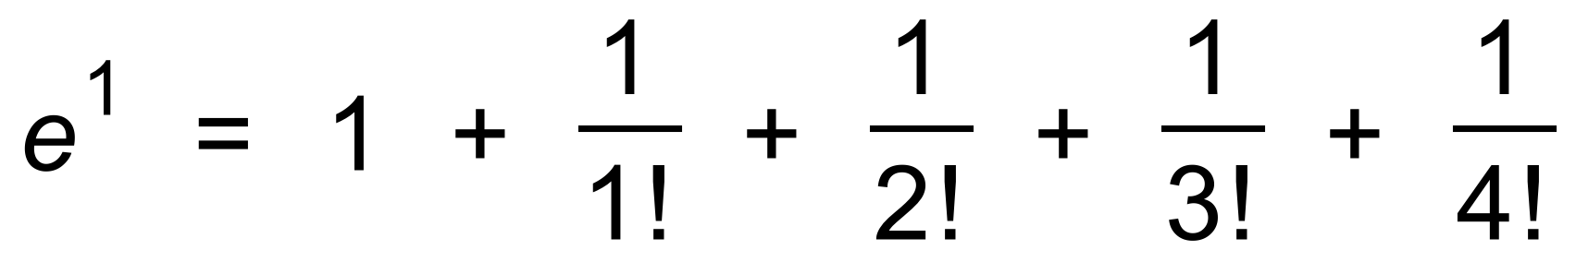
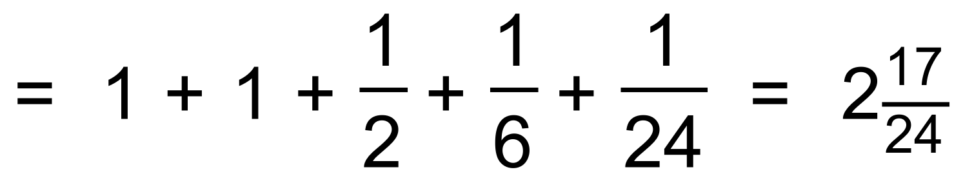
(b) 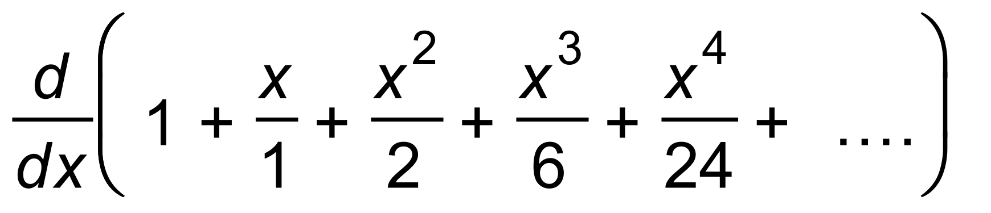
= 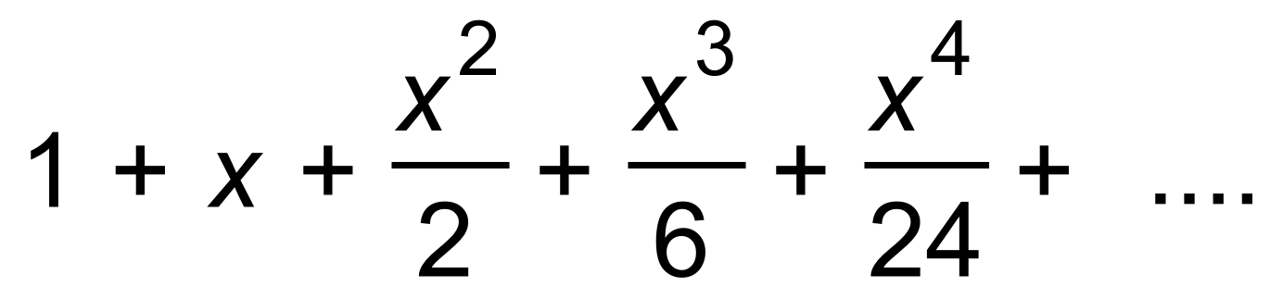
= 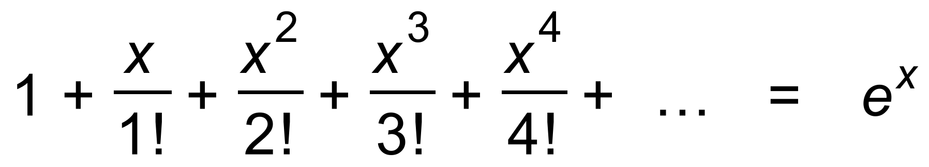 [4]

5. (a) 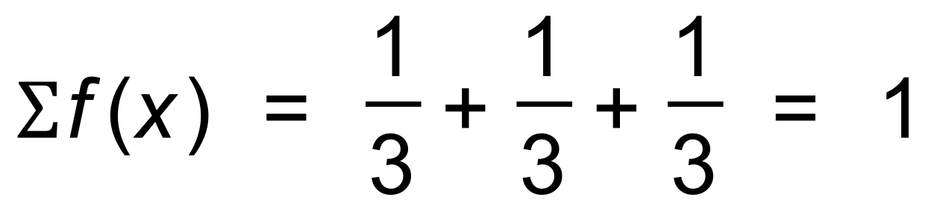
and 0 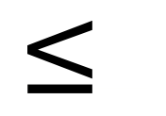 f (x) 0 for all x
∴ PDF
(b) 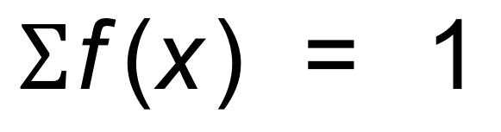
and 0  f (x) 0 for all x
∴ PDF
(c) Since 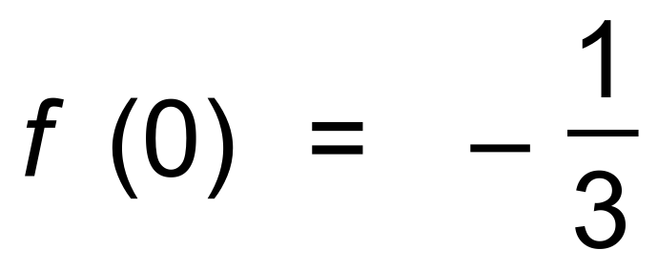
f (x) is not greater than or equal to 0 for all x
∴ Not PDF [6]

6. (a) Since PDF
(b) 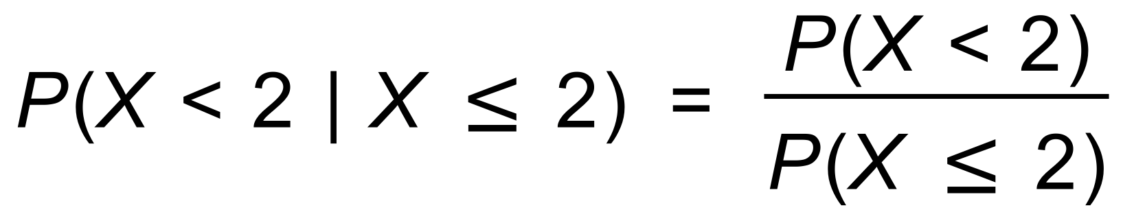
= 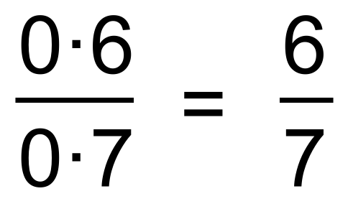
(c) E(X) = 0 + 0.1 + 0.2 + 0.3 + 0.8 = 1.4
(d) Variance = (0 + 1 x 0.1 + 4 x 0.1 + 9 x 0.1 + 16 x 0.2) − 1.4²
= 0.1 + 0.4 + 0.9 + 3.2 − 1.96 = 2.64 [8]

7. E(Y) = 2E(X) + 3 = 8
∴ m = 2.5
VAR(Y) = 4VAR(X) = 20
∴ v = 5 [3]

8. (a) 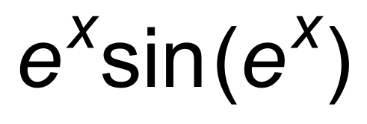
(b) 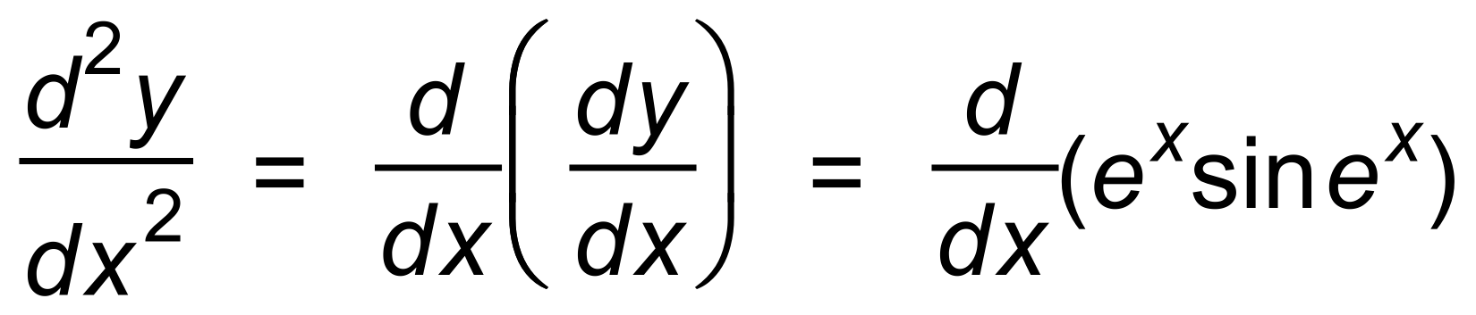
= 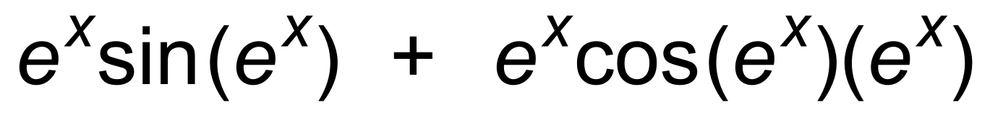 [5]

9. (a) 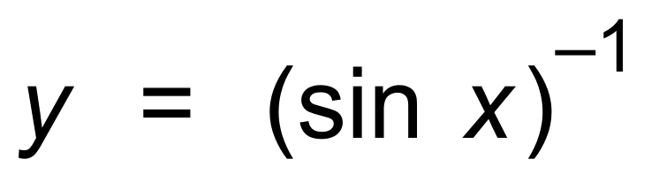
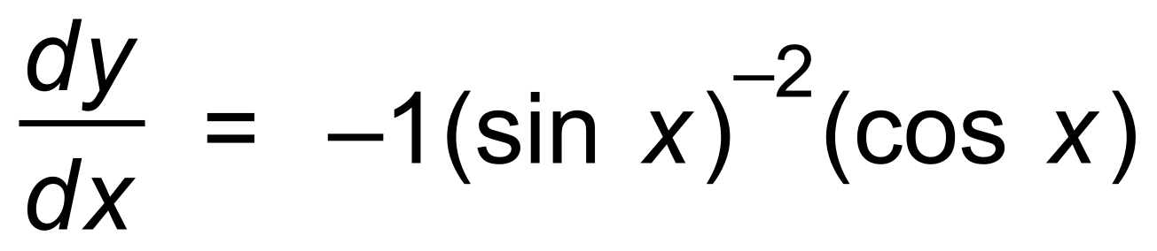
= 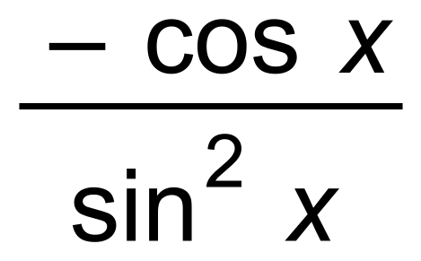
(b) 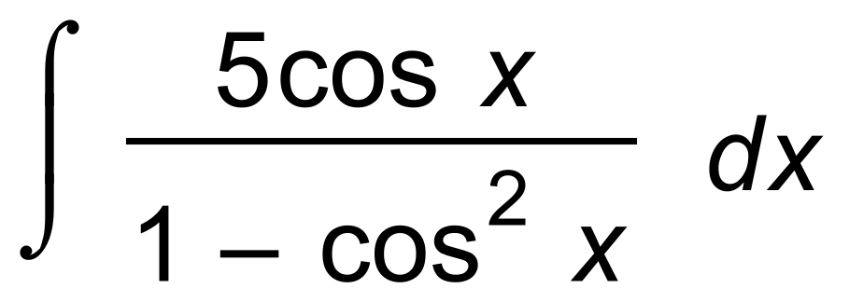
= 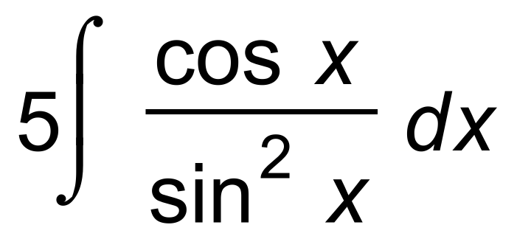
= 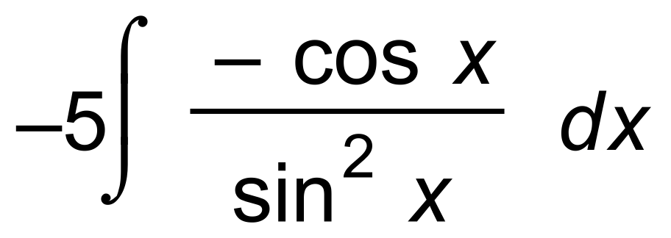
= 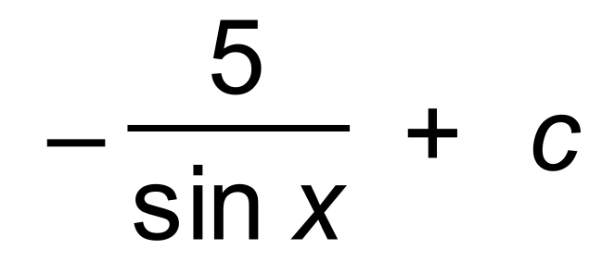 [5]

10. (a) 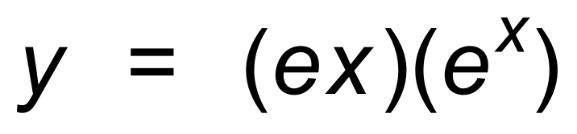
∴ 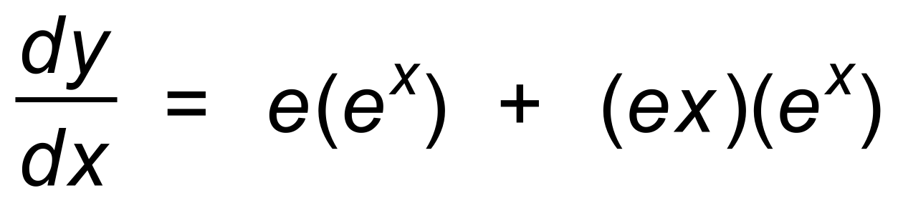
∴ = 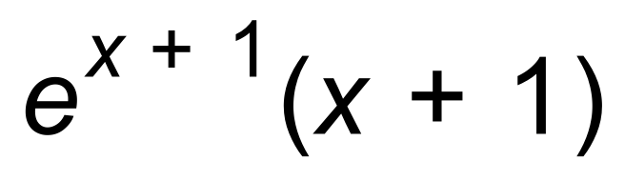
(b) 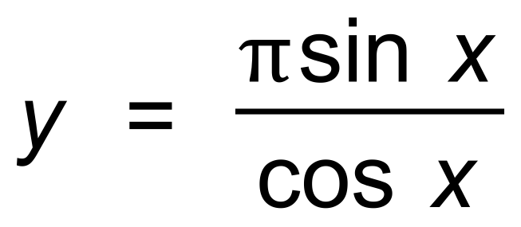
∴ 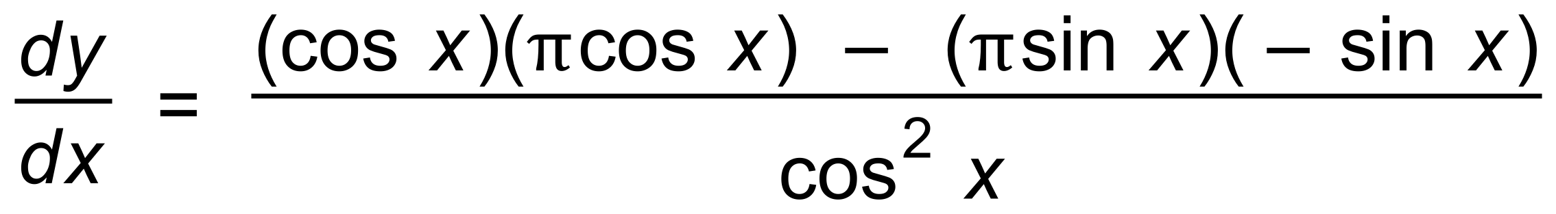
= 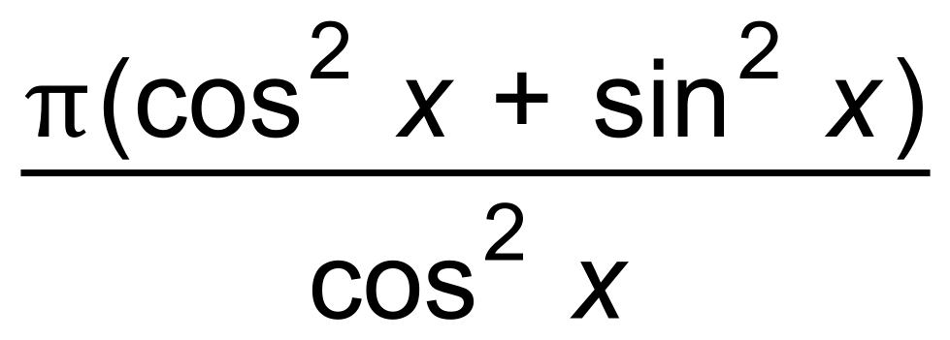
= 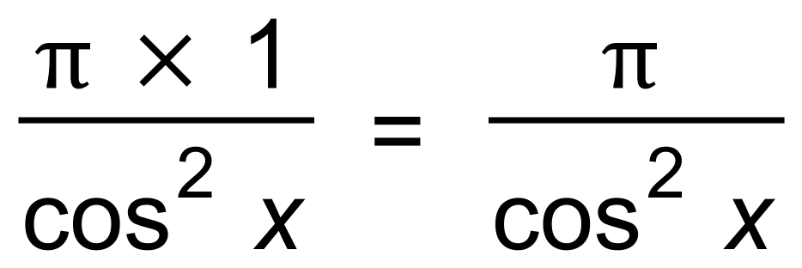 [5]

Calculator−assumed Solutions

11. (a) 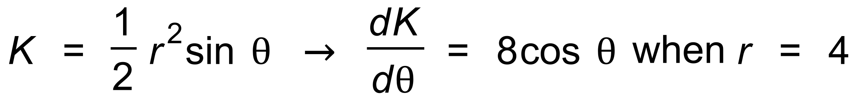
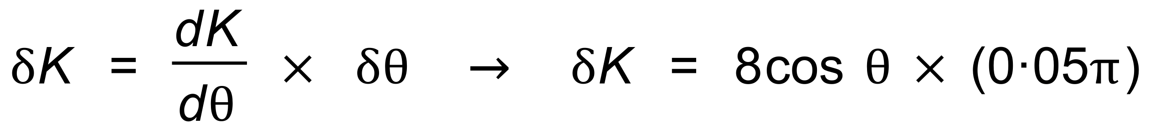
∴ 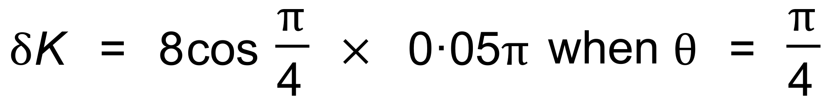
∴ 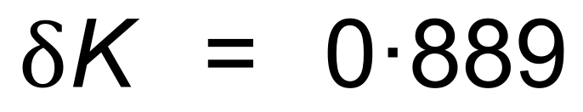
(b) 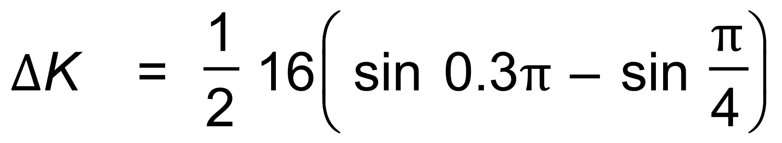
∴ 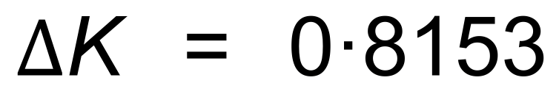
∴ 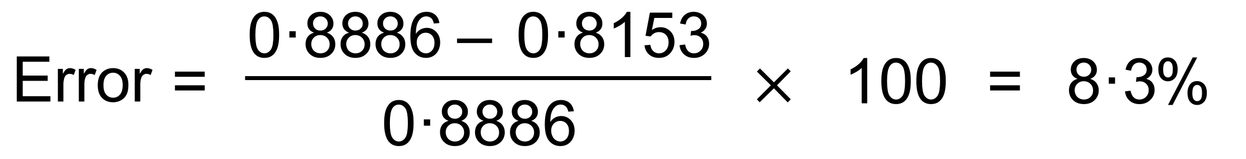 [5]

12. (−3, 0) → 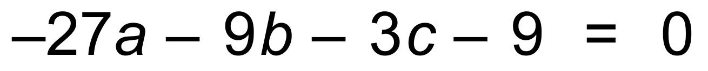
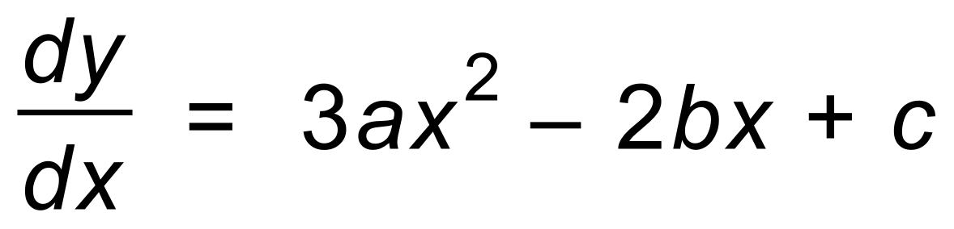
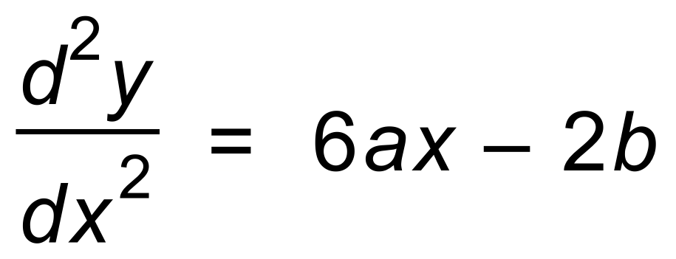
POI 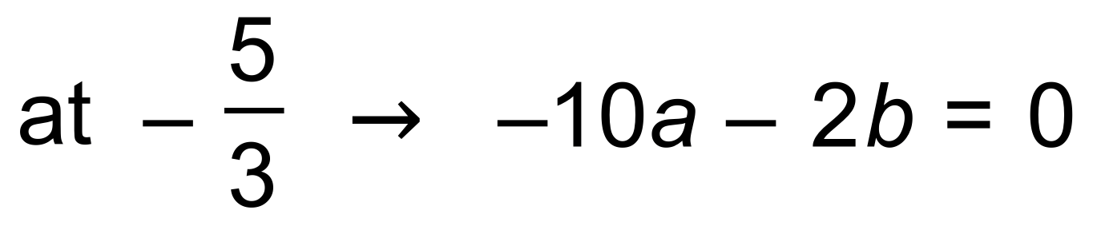
∴ Using calc [7]

13. (a) 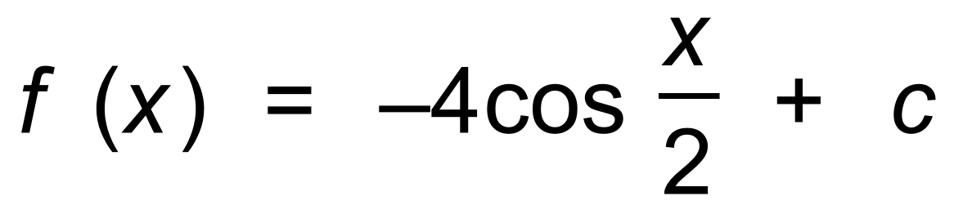
∴ 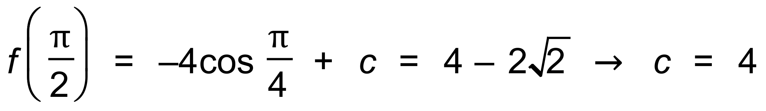
∴ 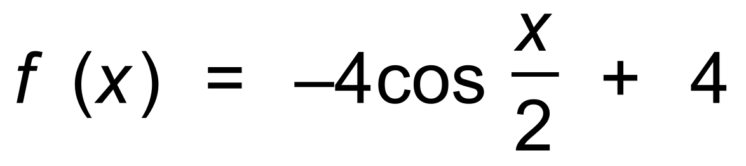
(b) 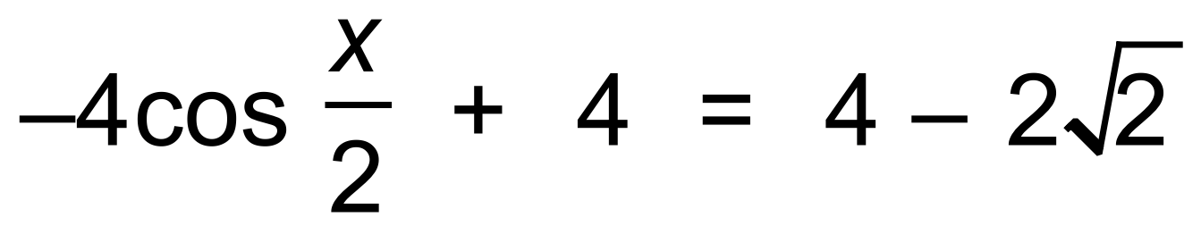
∴ 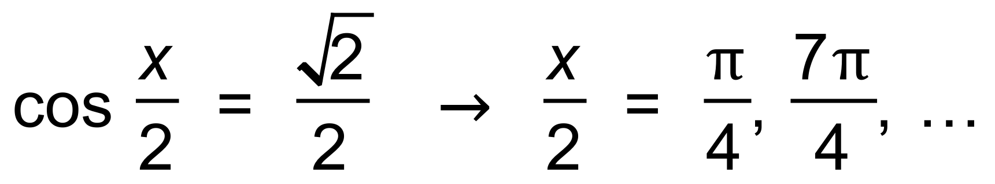
∴ Next time is 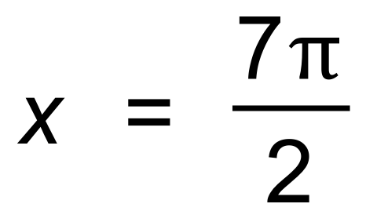 [6]

14. (a) (i) 0 + 1 + (−5) + 4 = 0
(ii) −3 + 1 + (−5) + 4 = −3
(iii) 1 + 5 + 4 = 10
(b) (i) 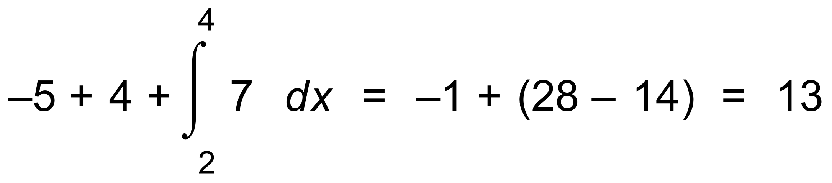
(ii) 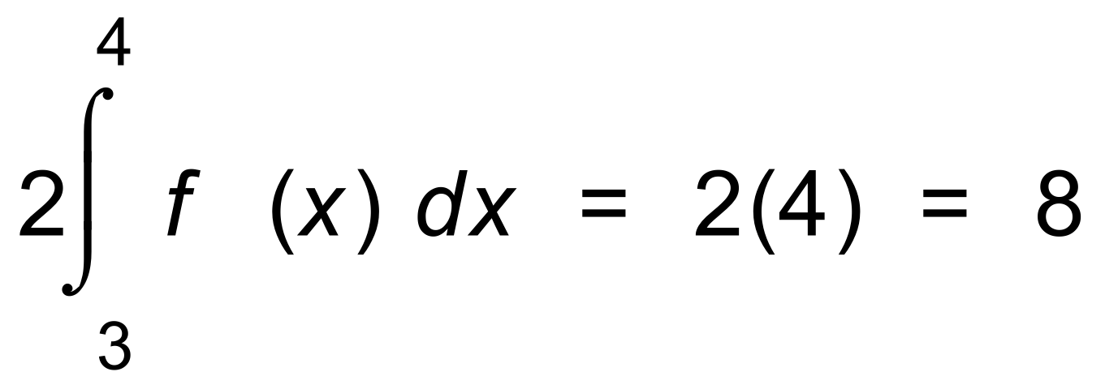 [10]

15. (a) (i)
∴ 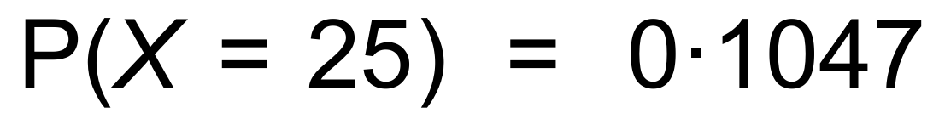
(ii) 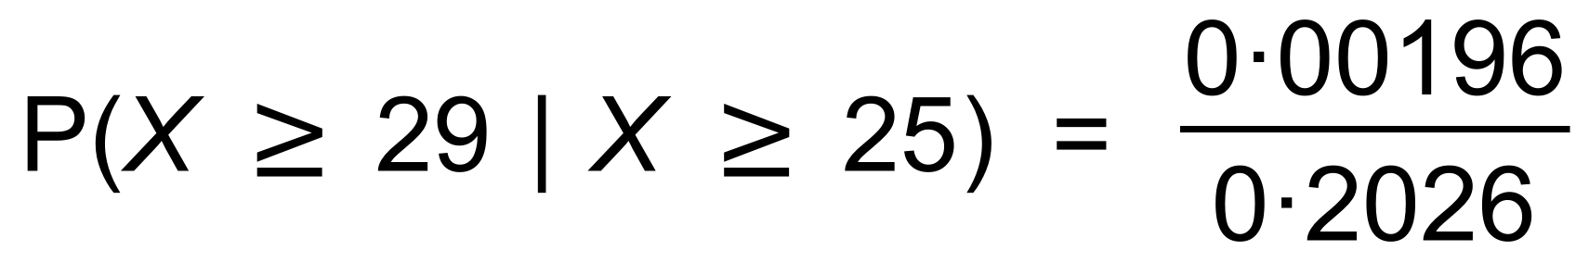
= 0.00967
(b) 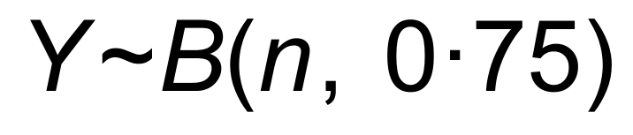 where Y is the number who graduated out of n
∴ using trial and error

n | Y
18 | 0.981
19 | 0.991
20 | 0.996

(c) (i) 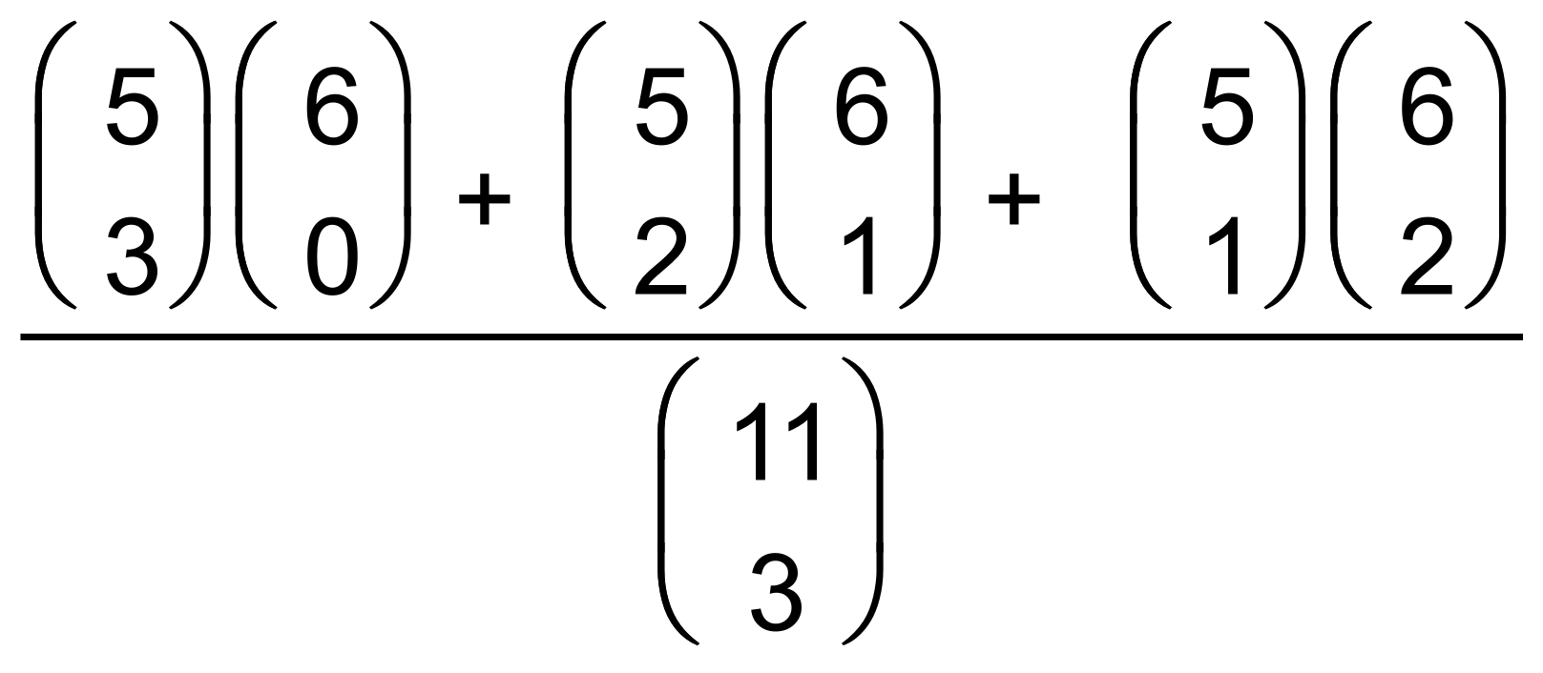
= 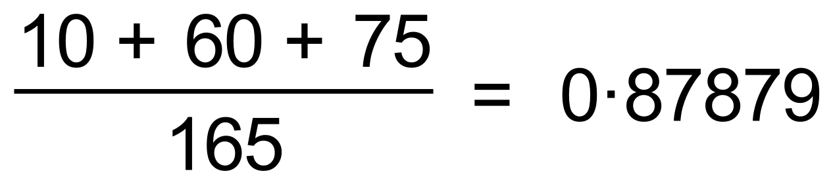
(ii) 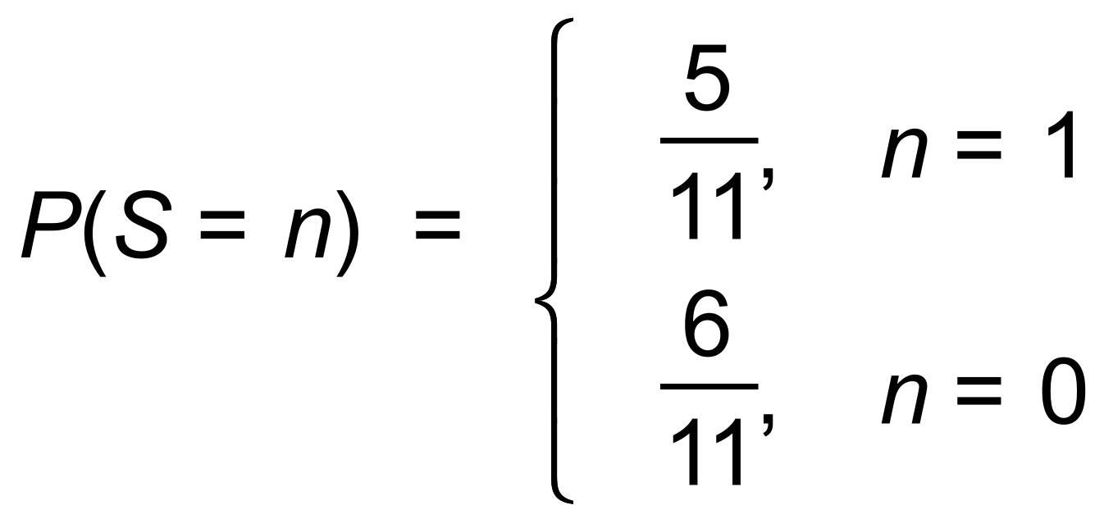 [15]

16. (a)
∴ 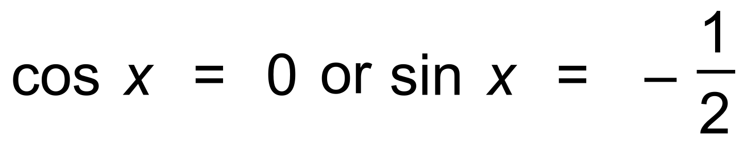
∴ 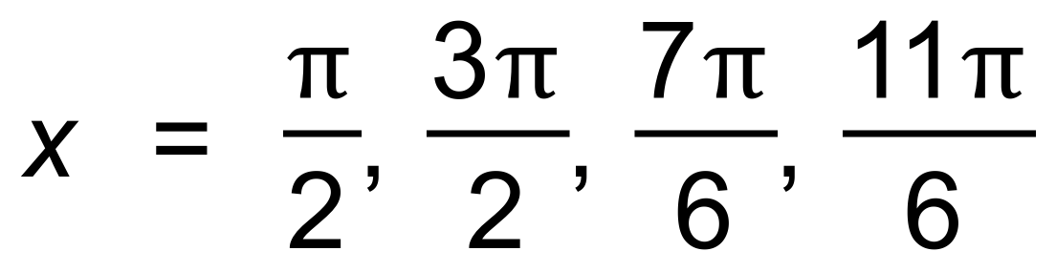
(b) 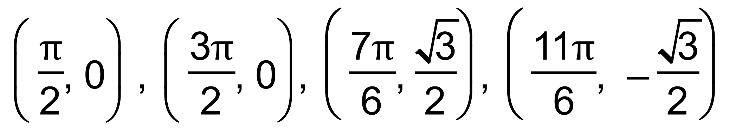
(c) A = 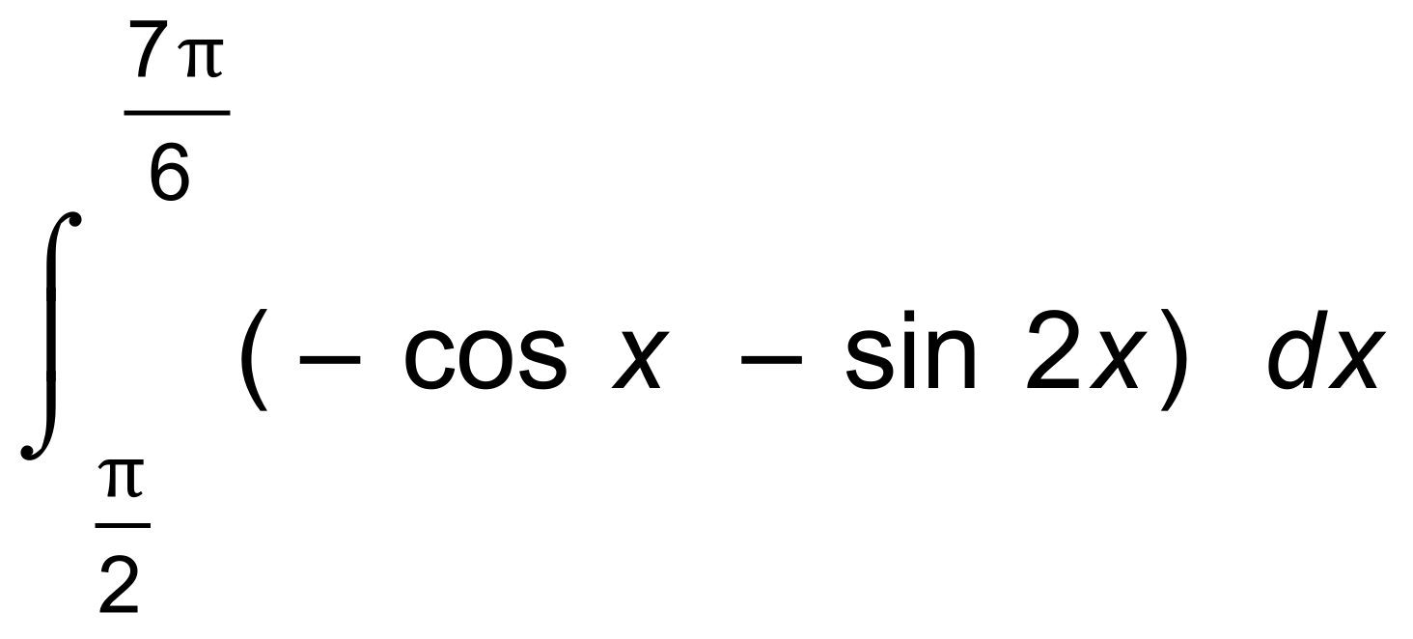
= 2.25 units² [6]

17. (a) 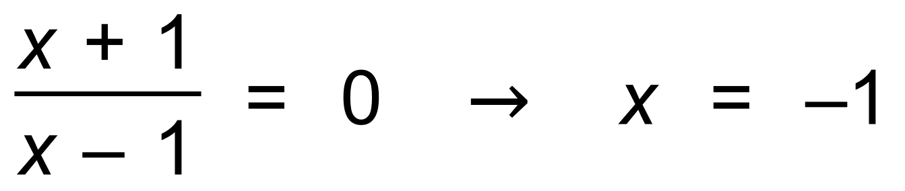
(b) (i) 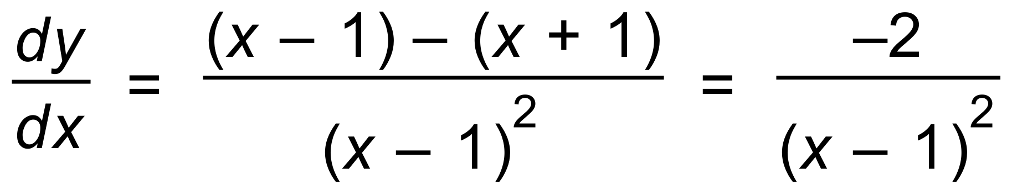
(ii) True since 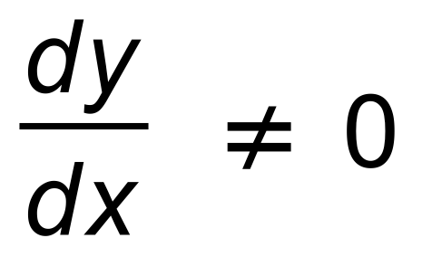 for any value of x.
(c) (i) 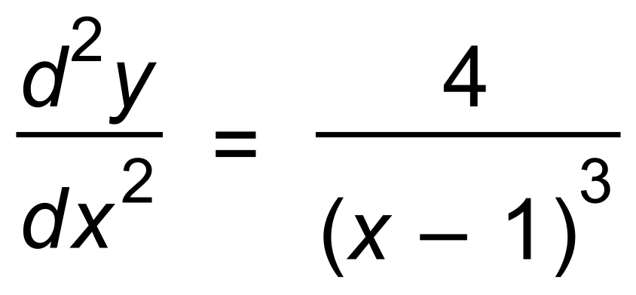
(ii) True since 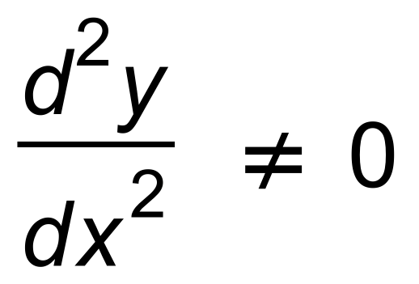 for any value of x. [5]

18. (a) 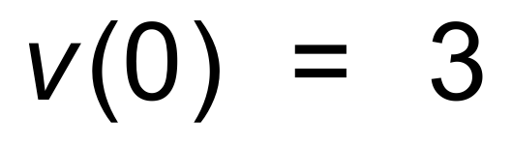
(b) 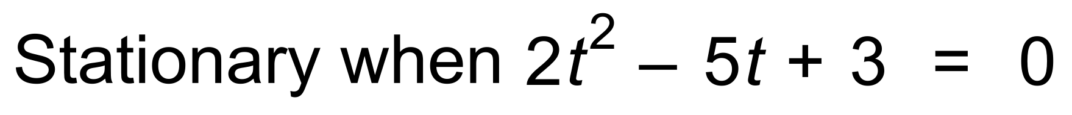
∴ t = 1 and 1.5
(c) (i) 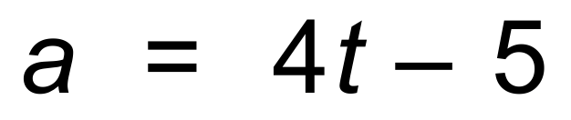
(ii)
(d) 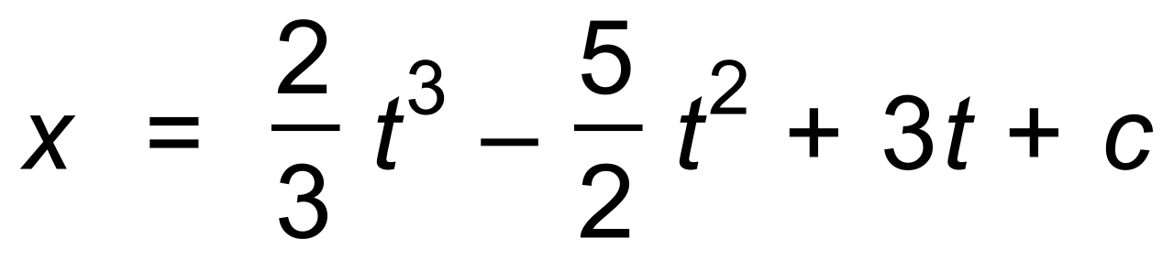
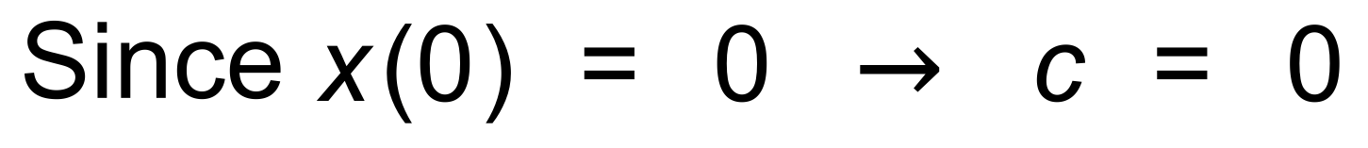
∴ 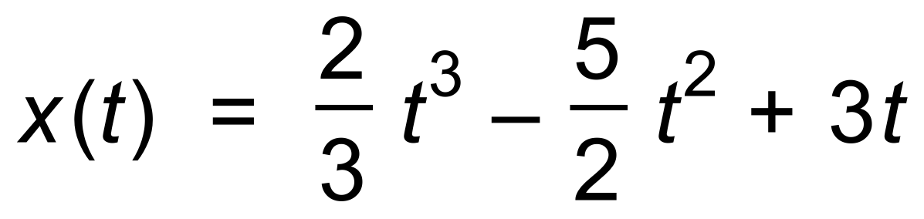
∴ 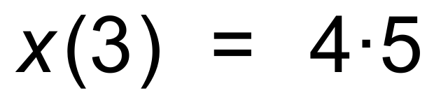
(e) 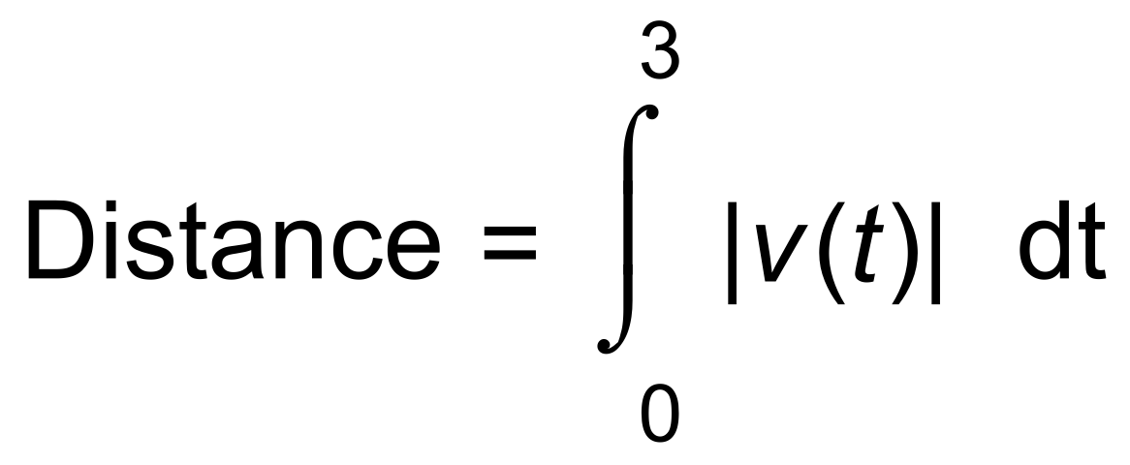
= 4.58
(f) Distance travelled ≠ Displacement [13]

19. (a) 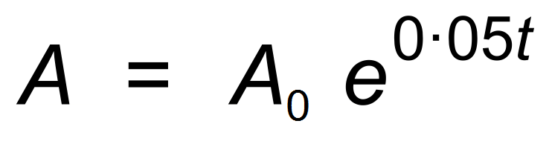
∴ 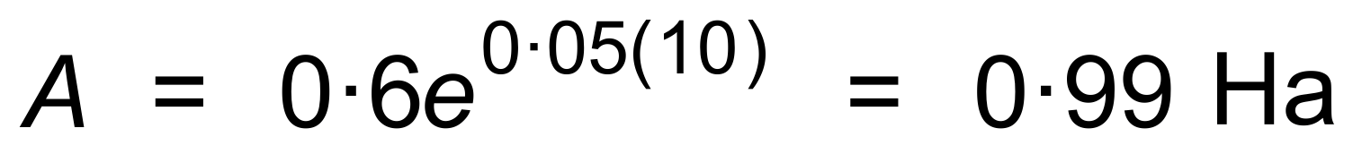
(b) 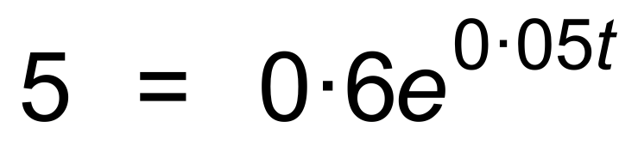
∴ t = 42.4 hours [6]

20. (a) (i) 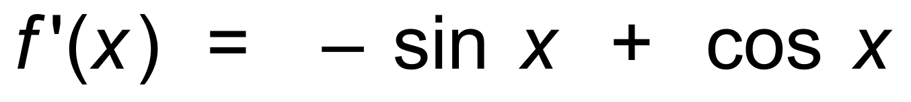
(ii) 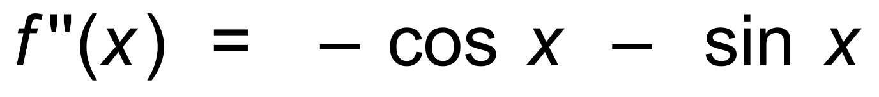
(b) Maximum value occurs when f ′(x) = 0
∴ 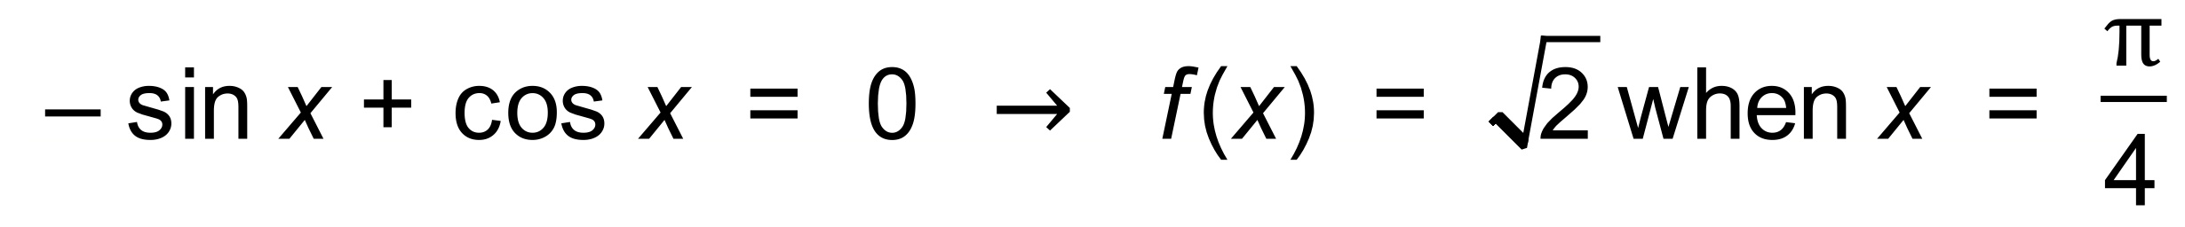
Since 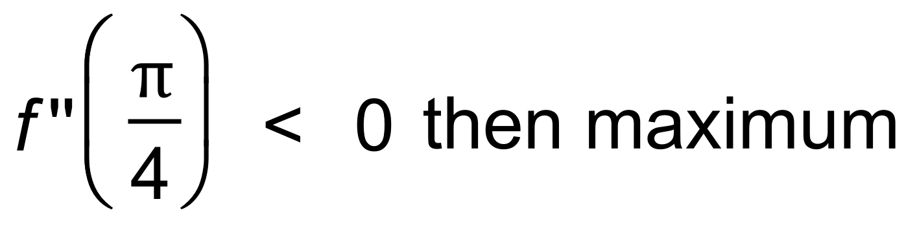
(c) POI occurs when f ′′(x) = 0
∴
∴ 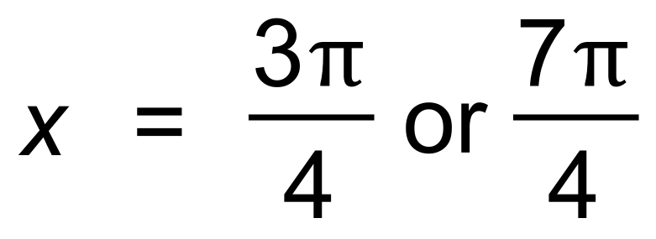
∴ 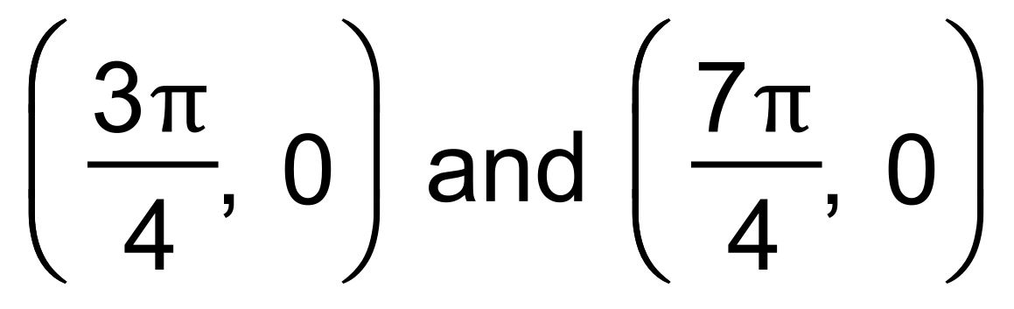 [10]

21. (a) 10 L/sec
(b) 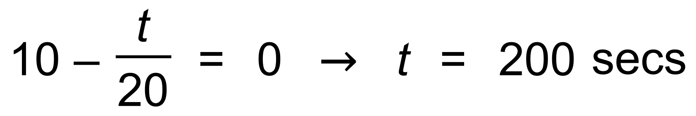
(c) 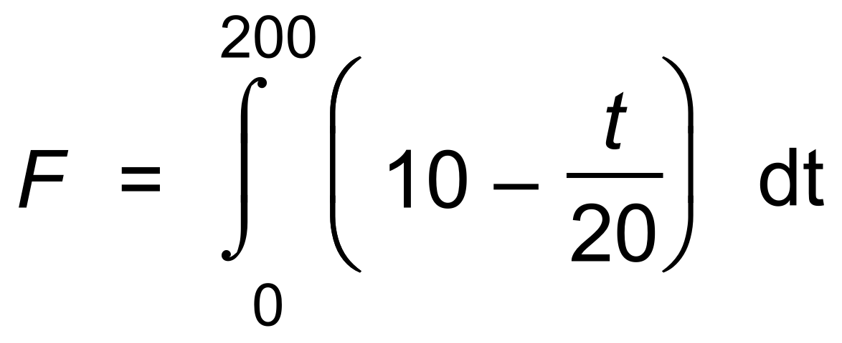
= 1000 L [4]

22. (a) 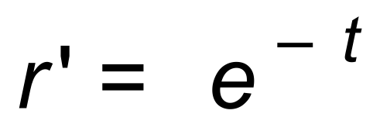
∴ 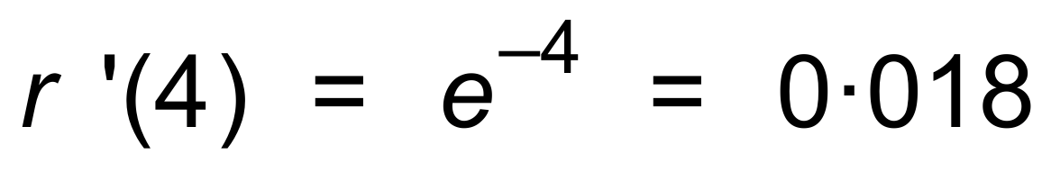
and 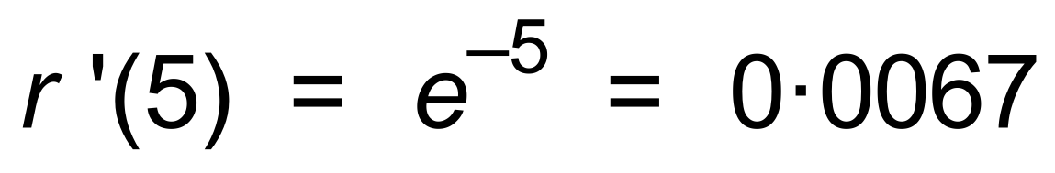
(b) 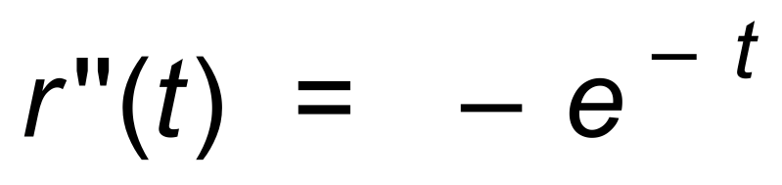
Since at its
greatest rate at the start of the fire,
Or the graph has greatest slope at t = 0.
(c) 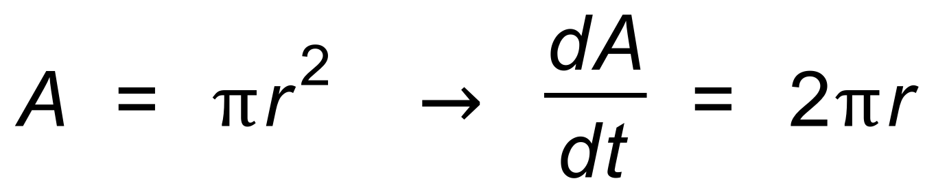
∴ 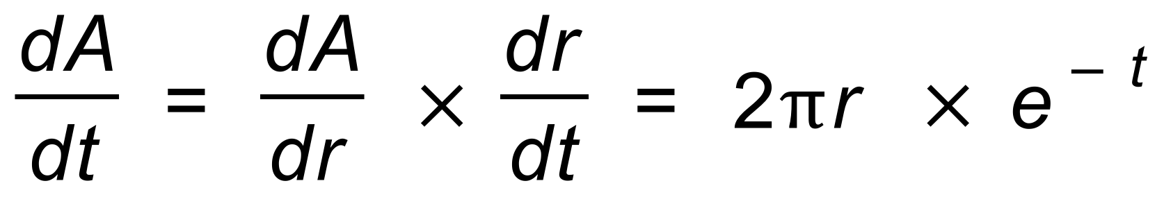
When t = 4 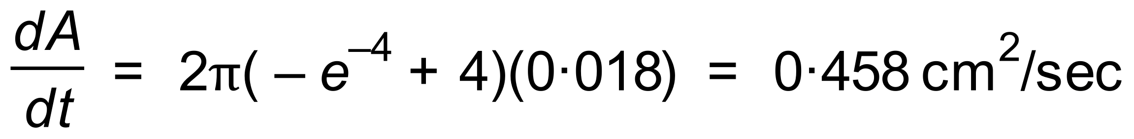 [9]

